USN: 2GI19CS175 Student Name: Venkatesh G Dhongadi

**Title of the Experiment:** Implementation of class and its member method

**Experiment No.**2 **Date: 0**2/10/2020

**Problem Statement:**

Design a class called Rectangle having two methods. First method named as setDim() takes length and breadth of rectangle as parameters and the second method named as getArea() returns the area of the rectangle. Length and breadth of rectangle are entered through keyboard.

**Objectives of the Experiment:**

1. Learn declaration and initialization of class and methods in Java

2. Learn how to declare objects of a class and access methods

3. Understand the use of class and methods in a real-life application

4. Learn how to pass parameters to a method

5. Learn to Display the result in a readable/proper format

**Program Source Code:**

/**

Design a class called Rectangle having two methods. First method named as setDim() takes length and breadth of rectangle

 as parameters and the second method named as getArea() returns the area of the rectangle. Length and

  breadth of rectangle are entered through keyboard.

 */

import java.io.*;

import java.lang.*;

import java.util.*;

///Class to initialize methods

class Rectangle

{

     //data members

    int length,breadth;

    float area;

    //member functions

    void setDim(int length,int breadth){

        this.length = length;

        this.breadth = breadth;

    }

    float getArea(){

        return length*breadth;

    }

}

//main class

class RectArea

{

    public static void main(String[]args){

        Scanner venki = new Scanner(System.in);

        Rectangle r = new Rectangle();       //object instantiation

        System.out.println("Enter the length of the rectanlge : ");

        int l = venki.nextInt();

         System.out.println("Enter the breadth of the rectanlge : ");

        int b = venki.nextInt();

        r.setDim(l,b);

        float a = r.getArea();

        System.out.println("Area is : "+a);

    }

}

**CASE 1:**

**Input:**

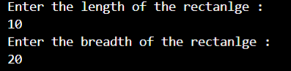

**Output:**



**CASE 2:**

**INPUT:**

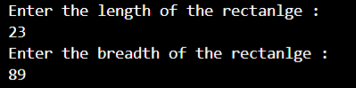

**OUTPUT:**



**Outcomes of the Experiment:** At the end of the laboratory sessions the students should be able to

1. Demonstrate the use of class and methods in solving real-life problems.

2. Identify appropriate method to be used for a particular scenario

3. Learn how to return values from a method

4. Initialize variables of a class using this keyword

5. Identify how to make a call for the method

**Conclusions:** From the given problem statement, we could identify the necessary variables and use the appropriate class and methods and the necessary program logic. We understood how to calculate the area of rectangle using methods. The program was written in Visual Studio Code by creating a project. We understood the usage of the IDE in typing the code, debugging, running the program and observing the output. We also understood the use of the built-in class System and its method println to display the result. The program was executed for two-three sets of input and results obtained were verified to be correct and recorded.

**PRACTICE PROBLEM**

Design a class called Circle having the following methods:

getRadius() to read the radius

computeArea() to compute the area of the circle

computePerimeter() to compute the perimeter of the circle

Declare the required instance variables appropriately.

**Program Source Code:**

/**

Design a class called Circle having the following methods:

getRadius() to read the radius

computeArea() to compute the area of the circle

computePerimeter() to compute the perimeter of the circle

Declare the required instance variables appropriately. */

import java.io.*;

import java.util.*;

import java.lang.*;

class Circle{

    float radius,area,perimeter;

    static float pi = (float)22/7;

    void getRadius(float r){

        this.radius = r;

    }

    float computeArea(){

        return ((pi)*radius*radius);

    }

    float computePerimeter(){

        return (2*(pi)*radius);

    }

}

class CircleArea{

    public static void main(String[]args){

        Scanner venki = new Scanner(System.in);

        Circle c= new Circle();

        System.out.println("\nEnter the radius of circle : ");

        float r = venki.nextFloat();

        c.getRadius(r);

        System.out.println("The Area of circle is : "+c.computeArea());

        System.out.println("The Perimeter of circle is : "+c.computePerimeter());

    }

}

**INPUT:**

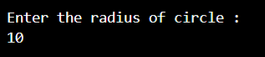

**OUTPUT:**

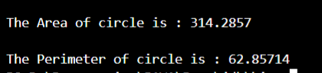

**CASE 2:**

**INPUT:**

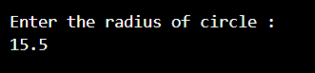

**OUTPUT:**

